

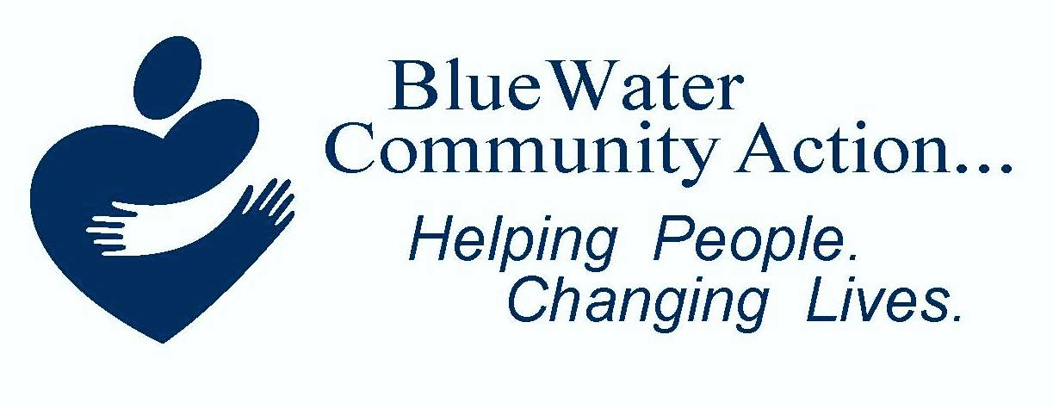

Annual Report 2025

October 1, 2024- September 30, 2025

Letter from the Director
Governance Foundation
Jorja Baldwin, Chairperson

Kevin Watkins,
Vice Chair

Randy Bennett, Treasurer

Bobbie Cutcher, Secretary

Barbara Payton
Benita Davis
Shannon McKeever
Sarah LaForge
Dave Vandenbossche
Linda Lilly

our tripartite board
As we reflect on the past year, one theme stands above all others: building.
Meaningful community impact requires a shared vision, a clear blueprint, a strong foundation, and skilled builders. Over the past several years, our agency has worked to rebuild its reputation through hard work, accountability, and an unwavering commitment to the communities we serve.
This progress would not have been possible without the dedication of our staff, the trust of our community partners, and the investment of our funders. Together, we have weathered a rapidly changing political and funding environment while remaining focused on our mission. Despite uncertainty, we continued to show up every day with determination and compassion.
Every success story, every household stabilized, and every individual moving closer to self-sufficiency represents another brick in the foundation of a stronger community.
While we are proud of what we have accomplished, we recognize that our work is not complete. The needs of our community continue to evolve, requiring innovative solutions and a willingness to adapt. As we look ahead, we are developing a blueprint for the future that focuses on promoting long-term family and agency stability. By investing housing stability, financial capacity, and community collaboration, we are helping create pathways that lead to lasting change.
The accomplishments highlighted in this report demonstrates what can be achieved when dedicated people work together toward a common goal. Every staff member, volunteer, partner organization, board member, and funder has played a role in helping us build stronger foundations and create new opportunities for the community.
Thank you for your continued support, trust, and partnership. Together, we are doing more than maintaining programs—we are strengthening our organization, rebuilding confidence, and creating a future where more individuals and families can achieve lasting self-sufficiency.
The foundation is strong. The framework is in place. And together, we are Helping People, Changing Lives
Karen Lake

Measuring Progress: One Brick at a Time!



$6,940,060 Non-CSBG Funds Expended
$315,045 CSBG Funds Expended
923 Outcomes Achieved
6017 Services Provided
1491 Households Served
2775 Individuals Served
ASSET DEVELOPMENT
Whether receiving homebuyer education, financial literacy, pre-purchase, or foreclosure prevention, our HUD-certified housing counselors create custom structural plans engineered specifically for the financial framework and unique life situations specific to each client.

EMERGENCY SERVICE
Whether through utility assistance, the Diaper Bank, the Community Care Closet, or the Back-to-School Backpack Program, our Emergency Services Specialist and supporting staff work diligently to support clients in crisis, deploying a full fleet of specialized support programs and services to relieve the crisis and strengthen the households in
need.

WEATHERIZATION ASSISTANCE PROGRAM
By braiding a variety of funding streams, the certified Weatherization Crew drafts the plans for each household’s energy saving measures, mobilizes certified contractors to install efficiency upgrades, and health & safety modifications from foundation to roof.

HOUSING ASSESSMENT RESOURCE AGENCY
Through supportive housing and homeless services The HARA crew drives the structural pilings for stable housing using the Housing First blueprint, while anchoring heavy-duty tie-backs to reinforce the clients' life framework.

Building the Framework:
Leveraging Partnerships!

"There are no problems we cannot solve together, and very few that we can solve by ourselves." — Lyndon B. Johnson

29- Committee Memberships
- Michigan State Regional Housing Plan Original Member  - Housing Ecosystem and Rental Housing Work Groups  - MIBOSCOC Governance Council  - MIBOSCOC Coordinated Entry Committee  - MIBOSCOC Shelter Committee  - MIBOSCOC HARA Committee  - MIBOSCOC Youth Committee  - Access Improvement Committee  - Data Learning Collaborative  - MIBOSCOC Performance and Outcomes | - Housing Support Service Workgroup  - Community Service Collaborative Body  - Community Service Collaborative Body Steering Committee  - Disaster Recovery Committee  - Navigation Resource Committee  - Adolescent Service Workgroup  - Great Lakes Migrant Resource Council  - HUD All Grantee Meeting  - ESP All Grantee Meeting  - MCA Executive Directors Meeting | - BWCA Fundraising Committee  - Blue Meets Green  - Blue Water Area Chamber Member  - Homeless Awareness Committee  - Port Huron Area Landlord Association  - United Way Affiliated Organization  - Non-profit Executive Directors Meeting  - Community Health Improvement Plan  - Blue Water Area Transit Local Advisory Council
1207- Staff Training Hours
Certification Achieved
2- ROMA Implementors, 1- Quality Control Inspector, 1- Energy Auditor, 1- MCA Leadership Institute

13- Events Hosted &/or Attended

- BWCA Back to School  - Walk for Warmth  - Point In Time Count  - Community Resource Fair  - Operation Transformation Family Night | - The Big Give  - Community Health Fair  - Texas Roadhouse Halloween Stroll  - Donuts with Deputies  - Boat Week Family Nite | - PH Housing Summer Block Party  - Neighbors Helping Neighbors  - Safe Horizon's Trick or Treat in the Park

Investors: Financial Overview

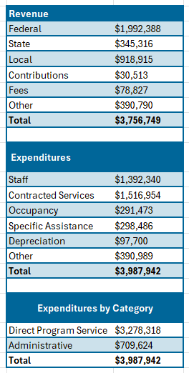

Blue Water Community Action’s financial audit
was prepared by
UHY, LLC
for the year-ended
September 30, 2025.
Blue Water Community Action was issued an unmodified opinion and qualified as a low-risk
audit.

The Ultimate Goal:
People Helped! Live Changed!

Ebony has been an FSS participant since 2021. She had recently become a single mother, lost her entire support system, and was starting over in a new town with her young, disabled son. She had been forced to drop out of school and struggled with job retention due to her son's high level of needs.
From day one, she was incredibly motivated, describing herself as following the bright spot in her future she could see on the horizon. At our first meeting, when I asked her what she wanted to set as a long-term goal, she thought for a moment, smiled, and answered "I just want some chickens in my backyard."
Since that first meeting, Ebony has been actively engaged both in the program and in deciding how her future will look. She's been thrown some hurdles along the way. Her son's needs have morphed as he's gotten older, but she is a quick and adaptive learner who handles every hiccup with grace and a smile. She put herself back through school, finishing semester after semester with honor roll, Dean's List accolades, and a 3.8+ GPA.
Ebony also put herself through trucking school, believing that working in an industry struggling to keep workers would provide job security for years to come. Unfortunately, she was in a devasting accident only a few short months after getting her own truck which made everything stop on a dime. After months of relentless physical therapy and procedures, Ebony regained her ability to walk independently. Ebony just finished her last semester to finish her associate’s degree in business, majoring in Supply Chain Management, rocking the honor roll and Dean's List all over again.
Through every hurdle life has thrown at her, Ebony has stayed true to her goal of homeownership and being financially literate. She has taken every class we offer about financial wellbeing and has utilized every resource I've given her to help her learn more than I can teach in a workshop. She lives and breathes the saying "don't sacrifice what you want most for what you want now." We recently met with MSHDA Key to Own who helped us round off the final stages of documentation so that Ebony can be approved for Key to Own lending, allowing her to transfer her rental voucher into a mortgage voucher. Ebony has been an excellent participant because of her drive, determination, and resilience. Homeownership won't be the end of her story - just a stop along the way.





Conclusion:
A Call to Action

As we conclude FY 2024-25, we are reminded that meaningful progress is built one connection, one resource, and one success story at a time. The accomplishments highlighted throughout this report reflect the dedication of our staff, the strength of our partnerships, and the resilience of the individuals and families we serve. As we look ahead, we remain committed to building opportunities, strengthening our community, and continuing the work that helps people move toward stability, independence, and hope. We invite you to continue building with us—through partnership, advocacy, volunteerism, and support—so that together we can strengthen services, expand opportunity, and create lasting impact for our community by…
Helping People and Changing Lives!

The Mission of Blue Water Community Action is to advocate for and provide individuals with limited income an opportunity to become self-sufficient .

Cultural Contract
We treat everyone with dignity and respect.
We are open and honest with each other.
We encourage initiative and forward thinking.
We set challenging, realistic goals, and deliver on our commitments.
We regularly communicate with each other on important issues and developments.
We develop and leverage the abilities and perspectives of all individuals in our diverse organization.
We make decisions that consider both the short-term and long-term needs of the agency and those we serve.
We involve the right people in making decisions and base them on what is best for the entire agency and those we serve.

In accordance with federal civil rights law and U.S. Department of Agriculture (USDA) policy, this
institution is prohibited from discriminating on the basis of race, color, national origin, age, disability, religion, sex, familial status, sexual orientation, and reprisal. To file a complaint of discrimination, write to: USDA, Assistant Secretary for Civil Rights, Office of the Assistant Secretary for Civil Rights, 1400 Independence Avenue, S.W., Stop 9410, Washington, DC 20250-9410. Or call toll‐free at (866) 632‐9992 (English) or (800) 877‐8339 (TDD) or (866) 377‐8642 (English federal‐relay) or (800) 845‐6136 (Spanish federal‐relay). Blue Water Community Action is an equal opportunity provider and employer.

